# SQL SERVER Architecture

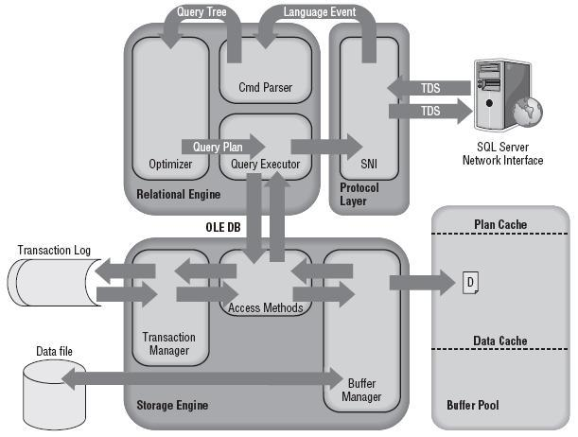

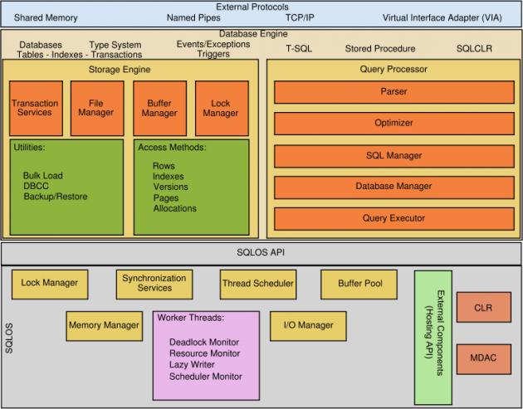

The major components of SQL Server are:

1. **Relational Engine**
2. **Storage Engine**
3. **SQL OS**

1) **Relational Engine:** Also called as the query processor, Relational Engine includes the components of SQL Server that determine what your query exactly needs to do and the best way to do it. It manages the execution of queries as it requests data from the storage engine and processes the results returned.

Different Tasks of Relational Engine:

1. Query Processing
2. Memory Management
3. Thread and Task Management
4. Buffer Management
5. Distributed Query Processing

2) Storage Engine: Storage Engine is responsible for storage and retrieval of the data on to the storage system (Disk, SAN etc.). to understand more, let’s focus on the concepts.

There are two types of files that are created at the disk level – *Data file and Log file*. Data file physically stores the data in data pages. Log files that are also known as write ahead logs, are used for storing transactions performed on the database.

**Data File**: *Data File* stores data in the form of *Data Page* (8KB) and these data pages are logically organized in extents.

**Log File**: It also known as write ahead log. It stores modification to the database (DML and DDL).

* Sufficient information is logged to be able to:
  + Roll back transactions if requested
  + Recover the database in case of failure
  + Write Ahead Logging is used to create log entries
    - Transaction logs are written in chronological order in a circular way
    - Truncation policy for logs is based on the recovery model

**SQL OS:** This lies between the host machine (Windows OS) and SQL Server. All the activities performed on database engine are taken care of by SQL OS. It is a highly configurable operating system with powerful API (application programming interface), enabling automatic locality and advanced parallelism. SQL OS provides various operating system services, such as memory management deals with buffer pool, log buffer and deadlock detection using the blocking and locking